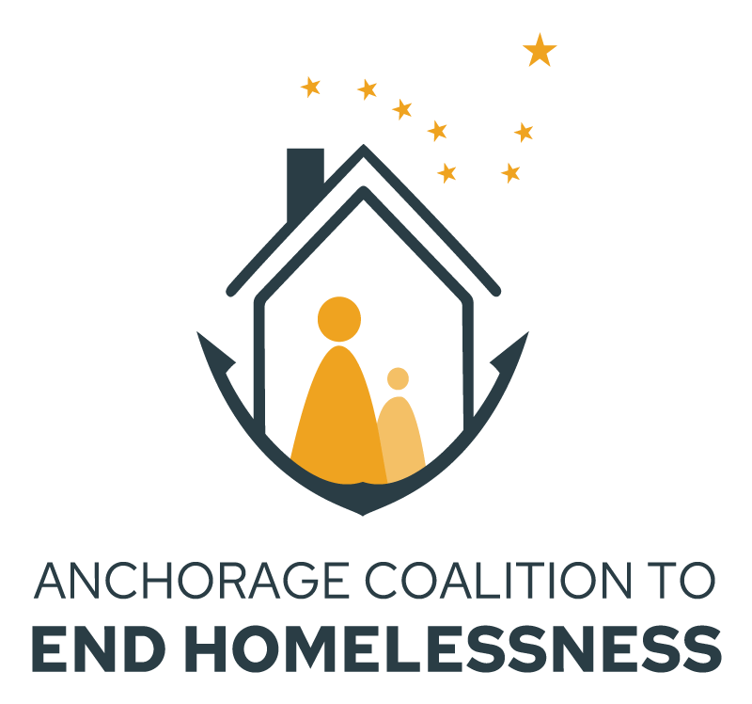

Anchorage (AK-500)

FFY 2023 HUD Continuum of Care Program

Local Competition

Renewal Project Application
Projects eligible for renewal will have an expiration date in 2024

NOFO Release Date: Thursday, July 5, 2023
Project Application Release Date: Wednesday, August 7, 2023
Project Application Due Date: Wednesday, August 25, 2023

HUD CoC Local Competition NOFO
The Anchorage Coalition to End Homelessness (ACEH) is soliciting Local Project Applications for the Federal Fiscal Year (FFY) 2023 Continuum of Care (CoC) Program funding competition.

Application Information
USE THE ACEH FFY23 NOFO RENEWAL APPLICATION INSTRUCTIONS!
This application has changed from last year to this year. The questions and rating will be aligned with the HUD NOFO requirements. Instructions, explanations, and context are provided in the ACEH instructions found here.

Application Support
Application support will be offered via Virtual Teams Meetings
- August Sessions – Thursdays from 2 pm to 3 pm: August 10, 17 and 24
Add to Calendar
- September Sessions – Thursdays from 2 pm to 3 pm: September 7, 14 and 21
Add to Calendar

Please send all questions regarding the application process to the ACEH grants email: grants@aceh.org.

Application Deadline
The FFY2023 CoC Project Application Packet is due to ACEH on Wednesday, August 25. If an agency is applying for more than one project, each project requires a separate project application form. For questions and application submissions, please email the ACEH grants email at: grants@aceh.org. A complete application packet will include:
- A completed Renewal Project Application
- Verification of 25% cash or in-kind match
- Project Budget
- Local Project Submission Agreement (coming soon)

All application packets must be sent as a PDF document with subject line: “SUBMISSION: <PROJECTNAME> AK-500 CoC Application”.

FFY2023 AK-500 CoC Local Project Renewal Application Form
APPLICATION DEADLINE: Friday, August 25, 2023

PART I: Project Information
Renewal Projects should have already completed and submitted an Intent to Renew form that captures project information. To identify this file with the correct project, please complete the lines below.
AK-500 Project Applicant Information
Agency (Grant Recipient) Name:

Project Name:

PART II: THRESHOLD REQUIREMENTS – Project & Agency
To be eligible for AK-500 CoC funding, the applicant organization must meet all threshold requirements. Threshold requirements and AK-500 CoC expectations can be found in the Applicant Pre-submission Agreement. Failure to meet the required thresholds or to review and commit to the entire Agreement will result in a reduction of points or a rejected application, as subject to the Ranking Committee. The organization must have received written acknowledgement of the receipt of their Applicant Pre-submission Agreement from ACEH before their Local Competition Application will be forwarded to the Ranking Committee.

You must verify that you have reviewed the agency and applicable project-type requirements for this renewal application and affirm that both your organization and this project meet them. They can be found in the NOFO beginning on page 55.

 |  | YES | NO
A. | I have reviewed the agency threshold requirements and affirm that our organization meets them.
B | I have reviewed the project threshold requirements and affirm that our project meets them. The project type is:____________________

PART III: PROJECT FOCUS AND COC BED COUNTS
THROUGHOUT THIS APPLICATION, BOXES WITH BLUE SHADING ARE NOT MEANT FOR DATA ENTRY. ONLY PUT YOUR ANSWERS IN BOXES WITH NO SHADING!

Is this project limited to only serving households that have experienced or are actively fleeing domestic violence, dating violence, sexual assault, stalking, or other dangerous or life-threatening conditions (including human trafficking)? ______YES ______ NO

 |  |  |  | YES |  |  | NO
1. | Does this project serve families?
 | a | How many total beds (not units) are included in the project?
 | b | Which of the following populations are served using these project beds?
 |  | Chronically Homeless Families
 |  | Veteran Families
 |  | Domestic Violence (DV) Families
 |  | Parenting Youth (24 or younger)
 | c | Of the total number of beds how many beds (not units) are CoC grant-funded?
 | d | Are the populations served with CoC-funded beds different than the ones indicated above? If yes, please explain:
2 | Does this project serve individuals, instead of or in addition to families?
 | a | How many total beds (not units) are included in this project?
 | b | Which of the following populations are served using these project beds?
 |  | Chronically Homeless Individuals
 |  | Veteran Individuals
 |  | Domestic Violence (DV) Individuals
 |  | Unaccompanied Youth (24 or younger)
 | c | How many beds (not units) are CoC grant-funded?
 | d | Are the populations served with the CoC-funded beds different than those indicated above? If yes, please explain:

PART IV: PROJECT PERFORMANCE AND UTILIZATION METRICS
You will find explanations for why we’re asking these questions, instructions on how to access the reports that contain these numbers from AKHMIS, and screenshots/images of what the applicable sections of these reports look like in the detailed instructions.

Project type: PSH
A1. Do you provide housing and services to individuals who have high service needs?
a. How many PSH beds do you have in this entire project?
b. How many PSH beds in this project are funded with a CoC grant?
c. How many of the CoC-funded beds are dedicated to only be used by those who experience Chronic Homelessness, as defined by HUD?
d. Divide c/b x 100 = percentage
A2. If your project has not yet completed a full project year, please answer based on the numbers as of the most recent measurement available to you.
a. What is the total number of all PSH clients this project served during the most recently completed project year?
b. What is the number of clients who remained housed with your project or exited to another permanent housing destination during the most recently completed project year?
c. Divide b/a x 100 = percentage%
A3. What % of your clients have remained in permanent housing over 2 years?
a. What is the number of persons in this project with a Housing Move-in date?
b. What is the number of persons remaining in the project of exited to a permanent housing destination?
c. What is the percentage of successful exits/retentions?

Project type: PSH & RRH
B1. How long does it take, on average, for your clients to access housing?
a. What is the total number of persons moved into housing?
b. What was the average length of time to being housed?
c. What is the number of persons who were exited without a move-in?
d. What is the total?

Project type: RRH & TH
C1. How effectively do you exit clients to permanent housing situations?
a. What is the total number of clients exited?
b. What is the number of clients exited to positive housing destinations?
c. What is the number of clients excluded from this calculations
d. What is the percentage of client exited to positive housing destinations?

Project type: TH
D1. What is the average # of days clients are enrolled in your project?
a. What is the average number of days for Leavers?
b. What is the average number of days for Stayers?

Project Type: All
This section will include clients who are receiving new income and those who have increased the dollar amounts of existing income
E1. % of project stayers with increased income
Stayers are persons who are active in the project on the last day of the report date range. For this calculation, please include all participants who have been in the project for at least one quarter.
a. What is the percentage of adult stayers with increased employment income?
b. What is the percentage of adult stayers with increased other income?
c. What is the total of adult stayers with increased income?
E2. % of project leavers with increased income/benefits
Project leavers are persons who exited the project and are no longer enrolled in the project as of the last day of the reporting period. This measurement should compare their income between their entry date and their program exit date.
a. What is the percentage of adult leavers with increased employment income?
b. What is the percentage of adult leavers with increased other income?
c. What is the total of adult leavers with increased income?
E3. Return to homelessness within 12 months of an exit to permanent housing.
a. What is the percentage of project participants who returned to homelessness within 12 months of exit to Permanent Housing. (As this requires two years of data, projects in their first renewal year will not have data available and shall report “N/A”).
E4. Referrals from Coordinated Entry (CE) Community-wide Prioritization List
a. What is the percentage of your clients that were entered as referrals from the CE Community-wide Prioritization List?

F. Daily Utilization Rate (All Projects)
Data below is to be completed based on Average Utilization on the last Wednesday of the months listed below. These numbers can be found in section 7b of the CoC APR – directions on how to access this report and what to look for can be found in the accompanying detailed instructions. This question measures how efficiently your project is using grant funds and ensures that project vacancies are being filled on a timely basis. It will also indicate how effectively your organization is participating in coordinated entry. Data entry delays or inaccuracies in HMIS will negatively affect this section:

Month |  | # of Beds Available? |  | Total served Reported in HMIS |  | Utilization Percentage
January 25, 2023
April 26, 2023
July 27, 2022
 | October 26, 2022
 | Average Percentage

G. Data Completeness & Timeliness
Enter the summary information regarding your project’s Completeness Percentages and Timeliness Percentages from the Data Quality score card that was sent to you by ICA in July. For more information, please refer to the detailed instructions.

Timeframe Reporting Period will be July 1, 2022 through June 30, 2023
UDE/AKSDE/DV/HUD Percentage
Annual Assessment Percentage
Entry Records Timeliness Percentage
Exit Records Timeliness Percentage

PART V: FINANCIALS

A. Grant Utilization
If funding was not received for the years listed below, put “N/A” in the “Total Line”. For the last Fiscal Year (FY), please detail your agency’s year-to-date expenditures up to the last completed fiscal quarter.
Please list YOUR ORGANIZATION’S grant start and end dates for this grant
(E.g.: July 1 – June 30)

 |  |  |  | Current Year – 2 |  |  | Current Year - 1 |  |  |  | Current Year
 |  |  |  | Grant Award | Funds Expended |  | Grant  Award |  | Funds Expended |  | Grant Award |  | Funds Expended
Operations
Leasing
Rental Assistance
Supportive Services
 | HMIS
 | Administrative
 | TOTAL
 | PERCENTAGE EXPENDED
 | Average percentage expended
The score will be based upon the Average Percent Expended in full grant terms. If two (2) years of data is not available, the score will be calculated based on the available year(s).

If any of the percentages expended is less than 95%, please explain:

B. CoC Funding Request
Proposed FY Project Budget: please note that “Match” funds must be at least 25% of the proposed project budget; additional funds are “leverage”. Project income may be included under “Match” or “Leverage”. In addition to completing the tables below, please attach a copy of your anticipated budget for this project. If you are interested in any budget line-item adjustments, please review the instructions for renewal applications for more information.

HUD Requested Budget for Project |  | Same as FFY22?
VAWA Expenses | $
Operations | $
Building Lease | $
Rental Assistance | $
Supportive Services | $
HMIS | $
Administrative | $
TOTAL | $
MATCH | $
LEVERAGE | $
PERCENT of Match + Leverage

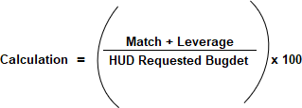

C. Match & Leverage Details
Provide detail of the total “Match” and “Leverage” indicated in PART V.B

Grant or Source Name | Amount | Pending / Confirmed | Cash / In- Kind | Direct / Indirect Costs | Use of funding | Match / Leverage / Medicaid
Add additional rows, as necessary.

PART VI: CoC Coordinated Entry Participation
Indicate your organization’s existing level of Coordinated Entry participation.

What is your referral region? ______________________________
 |  | YES | NO
A | Use the CoC common assessment tool which can be found here
B | Participate in case conferencing in your referral zone
C | Receive referrals from the local CE community-wide prioritization list  Number of referrals you’ve accepted since 1/1/23.
D | Have you filled 100% of your project vacancies with referrals from the CE community-side prioritization list? | F

PART VII: Utilization of Housing First Principles and Practice
Project applicant certifies that this is a low barrier project and that it operates in adherence with Housing First requirements.

 | Housing First Utilization | Yes | No
A | Project certifies that it is low barrier and adheres to Housing First requirements

PART VIII: Agency & Project Narrative Questions

- Project description (2500 characters):
a. Describe your project
b. How does it benefit the Homeless Prevention and Response System, and
c. How does it fit within the HUD priorities for the FFY23 NOFO?

- Description of the services provided to clients and the partners involved in the project:
a. Which services are provided through the project,
b. How often is the service offered (such as daily, weekly, monthly, as needed), and
c. Which partner agencies/organizations are involved in providing services.
a. Service | b. Frequency | c. Partners
Case management
Transportation
ID/Birth Certificate/SSN
SSI/SSDI application assistance
Medicare/Medicaid application assistance
Connection to mainstream supports (TANF, SNAP)
Mental health services

Substance use/misuse treatment
Physical health, primary care provider
Educational supports
Workforce training
Employment supports
Regional shareholder services
Follow-up/check-in

- Describe the project’s connection to and leveraging of the following resources:
a. Philanthropic or local funding sources,
b. Integration of healthcare resources within the project and connecting clients to healthcare (attach MOU in your application packet).

- Provide a summary of measurable performance goals for the project, such as
a. the number of clients to be served,
b. increases to income/benefits,
c. connections to other resources such as employment, job training, beneficiary services, transportation, etc.
d. Do you have a staff member helping clients who has been SOAR trained in the last 24 months?

- How is your organization addressing equity and inclusion for underserved communities, including
a. Black, Indigenous, and people of color,
b. Members of the LGBTQ2S+ community, and
c. People with disabilities?
d. How do you incorporate the feedback of those with lived expertise?

- Has your organization ensured that under-represented individuals (BIPOC, LGBTQ2S+, etc) are represented in the capacities listed below? If so, what actions have been taken prior to this funding competition? If not, what plans have been made to ensure equitable representation in the future?
a. Staff
b. Management
c. Decision-making positions/Board or Advisory Committee

PART IX: Local Application Certification
On behalf of the agency, I certify that I am authorized to affirm the responses in this application form and that the responses are all truthful to the best of my knowledge.

Name:

Electronic signature authorization (please check box): ☐
I agree that this box is the legal equivalent of my manual signature on this agreement.

Title:
Date:

